Chapter 5

The evolution and coexistence of divergent parasitization strategies

Ellen van Velzen, Rampal S. Etienne

Abstract

Superparasitism and multiparasitism refer to a parasitoid laying eggs in a host already parasitized by a conspecific or heterospecific female, respectively. Despite the obvious disadvantage of increasing resource competition for offspring, both behaviours are common in nature. One striking case is multiparasitism between the sibling species Nasonia vitripennis and N. giraulti: the latter prefers multiparasitizing over parasitizing an empty host. One possible explanation for this seemingly maladaptive behaviour is that N. giraulti economizes on its own venom production by taking advantage of venom injected by N. vitripennis. We explore the theoretical possibility of the evolution and coexistence of divergent parasitization strategies, using an individual-based simulation model with three evolvable traits: (1) level of venom production, (2) allocation of eggs to unparasitized and parasitized hosts, and (3) allocation of venom to unparasitized and parasitized hosts. Under a wide range of parameter combinations, but only when all three traits evolve simultaneously, we find evolutionary branching into two distinct parasitization strategies: the majority of the population produces a high level of venom, and only parasitizes unparasitized hosts; a minority produces little to no venom and only parasitizes parasitized hosts, taking advantage of the venom injected by the first female. But while evolutionary branching is common, subsequent stable coexistence of the two strategies is restricted to a narrow parameter space. We find that coexistence is promoted by a high cost of venom production and low levels of within-host competition. We discuss our results in the context of microsympatric coexistence in the Nasonia system.

Introduction

Parasitoids are well known to make oviposition decisions based on host characteristics determining its quality, such as species (Haeckermann et al. 2007) or size (Godfray 1986; Hardy et al. 1992; Zaviezo and Mills 2000; Wang et al. 2008), preferentially laying eggs in hosts of high quality to their offspring. One important characteristic determining quality is whether the host has been parasitized before. As resources within the host are limited, laying eggs in a host that has already been parasitized by a conspecific female (superparasitism) or heterospecific female (multiparasitism) yields an obvious disadvantage to offspring fitness. While this is expected to be most severe in solitary parasitoids, where only a single offspring can emerge from a host, it is costly in gregarious parasitoids as well: brood size is negatively correlated with larval survival and body size of emerging adults (Hardy et al. 1992; Vet et al. 1994; Alleyne and Beckage 1997; Rabinovich et al. 2000). Yet despite the ability to discriminate between parasitized and unparasitized hosts being ubiquitous (Dorn and Beckage 2007), superparasitism is common in nature (van Alphen and Visser 1990; Godfray 1994).
Superparasitism is expected to occur when the benefits outweigh the costs; for example, it can be a more efficient strategy when competition over hosts is high and unparasitized hosts are difficult to find, even when the payoff from superparasitized hosts is lower (Parker and Courtney 1984; Visser et al. 1992; Weisser and Houston 1993). In addition, there are various potential advantages to superparasitism that can offset the cost of higher competition. For example, in solitary parasitoids, the second egg can have a higher chance at overcoming the host’s immune response (Bakker et al. 1985). In gregarious parasitoids, similar advantages can be found: in Metaphycus flavus, superparasitizing increased parasitoid offspring survival by lowering encapsulation rates, and gave a strong advantage to superparasitizing provided the interval between parasitizations was not too long (Tena et al. 2008). Similarly, self-superparasitism was found to be advantageous in Macrocentrus grandii because it decreases the probability of total brood failure (White and Andow 2008). Finally, superparasitizing females can benefit from the venom injected by the first female (Dorn and Beckage 2007), potentially allowing them to economize on their own investment in venom production.
Although multiparasitism has been less well studied than superparasitism, numerous examples of it can be found in nature. The same general arguments about the costs of sharing a host with conspecifics apply to heterospecifics, although avoidance of multiparasitism does not always occur even when the cost is high (de Vis et al. 2003; Mahmoud and Lim 2008; Magdaraog et al. 2013). Interspecific host discrimination is rare compared to intraspecific host discrimination, and is mostly limited to recognizing hosts parasitized by closely related species (Wylie 1970; Vet et al. 1984), although some studies have reported a stronger avoidance of multiparasitism than of superparasitism (van Baaren et al. 1994; Ivens et al. 2009). Advantages to multiparasitism have also been observed, albeit rarely: for example, there are several cases in which the multiparasitizing female benefits from viruses or venom injected by the first female, dramatically increasing her offspring’s survival when multiparasitizing (Guzo and Stoltz 1985; Cusson et al. 2002). One particularly interesting case is Nasonia giraulti, occurring in close sympatry with its sibling species N. vitripennis, which appears to prefer multiparasitizing over parasitizing an unparasitized host (S. Pérez-Vila et al, accepted).
Nasonia are a genus of gregarious parasitoid wasp species, laying several eggs in one host. They parasitize cyclorraphous flies found in bird nests and at carcasses, and are the main parasitoids of species in the Protocalliphora genus that parasitize young birds. Individuals mate at emergence on the natal patch (with the exception of N. giraulti, which mates almost exclusively within the host), after which females disperse to find suitable hosts (Whiting 1967). Four Nasonia species have been described, of which three have a limited geographical distribution: Nasonia longicornis in Western North America, and N. giraulti and N. oneida which occur sympatrically in Eastern North America. They all co-occur with the fourth species, N. vitripennis, which has a worldwide distribution (Darling and Werren 1990).
Both N. longicornis and N. giraulti occur in sympatry with N. vitripennis, but their competitive interactions are very different. Multiparasitism in the field between N. vitripennis and N. longicornis is rare (Grillenberger and Ivens, unpublished data), and a host choice experiment confirmed that both species avoid multiparasitizing more strongly than they avoid superparasitism (Ivens et al. 2009). In contrast, N. giraulti is in the field always found co-occurring in nests with N. vitripennis, and multiparasitism rates are high (Grillenberger et al. 2009 , Pérez-Vila et al in prep). Even more surprisingly, a host choice experiment has shown that while N. vitripennis avoids multiparasitizing (though less strongly than it avoids superparasitizing), N. giraulti prefers multiparasitizing over attacking an empty host (Pérez-Vila et al., accepted).
While the effect of host crowding on offspring fitness has not been well studied in N. giraulti, in N. vitripennis overcrowding leads to smaller offspring (Rivero and West 2005; Sykes et al. 2007), and body size is correlated with longevity as well as fecundity (Flanagan et al. 1998; Rivero and West 2002; Sykes et al. 2007), suggesting host sharing comes at a cost.
With multiparasitism clearly being costly, N. giraulti’s seemingly maladaptive parasitism strategy calls for an explanation. It is possible that multiparasitizing confers an advantage large enough to offset the cost. For example, by multiparasitizing, N. giraulti might take advantage of venom injected by N. vitripennis females, allowing it to economize on its own venom production. While little is definitively known about the levels of venom production and their efficiency and costliness for each species, N. giraulti’s closest sibling species N. oneida performs poorly when parasitizing on its own compared to when several females are allowed to parasitize simultaneously (S. Pérez-Vila, personal communication), suggesting a lowered ability to successfully parasitize a host by itself. This leaves us with two questions. First, can this difference in parasitization strategies explain coexistence in the field, despite the strong interspecific competition caused by the high multiparasitism rate? And second, given that N. giraulti is a sibling species of N. vitripennis that possibly evolved sympatrically (Drapeau and Werren 1999; Desjardins et al. 2010), can this be a mechanism through which sympatric speciation can occur?
Existing theoretical models on superparasitism in gregarious parasitoids have generally approached the issue from an optimal foraging viewpoint (Iwasa et al. 1984; Parker and Courtney 1984; Skinner 1985; Strand and Godfray 1989), predicting females should adjust their clutch size to lay fewer eggs when superparasitizing. However, these models are very simple, not taking into account any other potential effects of superparasitizing on offspring fitness. In this study we develop a more complex model on the evolution of clutch size on unparasitized and parasitized hosts, allowing this to co-evolve with a second trait, venom production, which is assumed to be costly. The most important question we seek to answer is whether we can find evolutionary branching; what conditions promote branching, and whether it leads to stable coexistence of different parasitization strategies.

Model

We used an individual-based simulation of host-parasitoid interactions with non-overlapping generations. The ecological host-parasitoid dynamics are based on the Nicholson-Bailey model (Nicholson and Bailey 1935), in which encounters between hosts and parasitoids follow a statistical distribution, typically assumed to be a negative binomial distribution (May 1978). The details of the ecological dynamics are described below under simulation setup.

Traits under selection

Each individual has three traits, which together determine its decisions when encountering a host (how much venom to inject and how many eggs to lay), depending on whether or not the host has been parasitized before.

1. Venom production
During parasitism, the parasitoid injects venom to paralyze and kill the host. The production of venom can be assumed to be costly and trade off against another life history trait; here, we assume that venom production is energetically costly and trades off with egg production, so that there is a direct trade-off between fecundity and venom production:
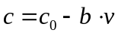
Here, 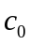 is the maximum fecundity if no energy is spent on venom production; v is the amount or the effectiveness of venom produced; and b is the costliness, or the loss in fecundity per unit of venom produced.

2. Clutch size / host preference
Studying the evolution of clutch size in the context of a possible facilitative effect of superparasitism, our focus is on the evolution of host preference, expressed as relative clutch size. Like previous models (Iwasa et al. 1984; Parker and Courtney 1984; Strand and Godfray 1989), we assume parasitoids do not avoid superparasitizing, but adjust their clutch size depending on the quality of the host they encounter (parasitized vs. unparasitized). What we study in this model is in which direction they adjust clutch size (laying more eggs in unparasitized or in parasitized hosts) and the strength of this preference.
The average number of eggs a parasitoid lays per encounter is given by her fecundity c, as calculated in eq. (1). We assume a direct trade-off between clutch size for unparasitized and clutch size for parasitized hosts: if a female increases her clutch size when encountering an unparasitized host, she will have to lay fewer eggs in parasitized hosts she encounters, and vice versa. This scenario can describe proovigenic parasitoids, which have a fixed number of eggs they can lay in their lifetime, and have to divide them over the hosts they encounter in such a way as to maximize fitness. However, it also includes synovigenic species in which eggs mature at a fixed rate, as long as this rate is slow enough to cause egg limitation (Heimpel and Rosenheim 1998). The clutch size decisions are calculated as described below.
Because the average number of eggs laid over all encounters is assumed constant, the following condition holds:
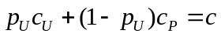
Here, 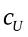 and 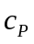 are the clutch sizes laid in unparasitized and parasitized hosts, respectively.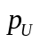 is the probability, for any encounter between a host and parasitoid, that the host has not been previously parasitized. It can be calculated following the Nicholson-Bailey interaction dynamics, and corresponds to the total number of hosts encountered, divided by the total number of encounters in the population:
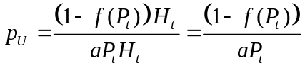

Here, 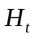 and 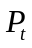 denote host and parasitoid abundance, respectively, and a the parasitoids’ search efficiency; 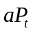 is thus the encounter rate, corresponding to the average number of encounters per host.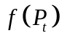 is the escape function, or the fraction of hosts that avoid parasitism. This fraction is given by the zero term of the negative binomial distribution:
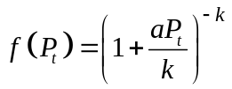.
Here, k is the parameter that describes the degree of aggregation of encounters, with 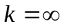 corresponding to completely random encounters, and smaller values of k corresponding to stronger aggregation. Some degree of aggregation is generally assumed, caused by nonrandom spatial distribution of the hosts; stable host-parasitoid dynamics are found when k ≤ 1 (May 1978).
The probability decreases as the superparasitism rate increases; thus it decreases with parasitoid population size and attack rate a, but increases with k. The clutch sizes 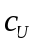 and 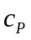 for each parasitoid depend on and on its preference trait, here called 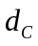 for “clutch division”. They are calculated as follows:
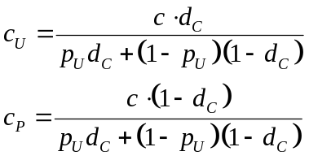
takes a value between 0 and 1, where = 0.5 corresponds to no preference (laying the same number of eggs in parasitized and unparasitized hosts). 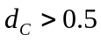 denotes a preference for unparasitized hosts, and 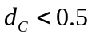 a preference for parasitized hosts; 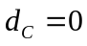 and 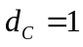 correspond to the extremes of only laying eggs in parasitized and only laying eggs in unparasitized hosts, respectively.

3. Division of venom
Just as a parasitoid can adjust its clutch size based on information about a host’s parasitization status, it can likely adjust the amount of venom it injects. The third parasitoid trait, called 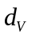 for “venom division”, determines how it chooses to divide the venom it produces over unparasitized and parasitized hosts. Analogous to the host preference trait, this results in two values 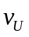 and 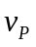 determining how much venom an individual injects into unparasitized and parasitized hosts, respectively. They are calculated in the same manner as the clutch sizes:
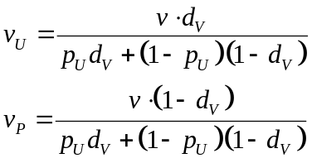
Like the host preference trait described above, takes a value between 0 and 1, with = 0.5 corresponding to equal division over unparasitized and parasitized hosts.

Simulation setup

In our simulation the three traits under study, v (venom production), d_{c} (preference) and (venom division), are each represented as a single continuous allele determining each individual’s life history traits as described above. Simulations were run for 50,000 generations; per parameter combination studied, 50 replicate simulation runs were performed.
Each generation consists of three steps: (1) distribution of encounters over the hosts and subsequent parasitism; (2) competition between larvae over resources in the host, determining the number of offspring per parasitoid; and (3) inheritance and mutation.

1. Distribution of encounters and parasitization
At the beginning of each generation, the number of encounters for each host is drawn from a negative binomial distribution with mean and aggregation level k. After this, per host, for each encounter a parasitoid is drawn randomly from the population. For the first encounter (i.e. when the host is still unparasitized), it lays a number of eggs drawn from a Poisson distribution with 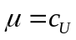 and injects an amount of venom , where and are determined by that individual’s inherited traits. If during the first encounter no eggs are laid, the parasitoid injects no venom and the host remains unparasitized for its next encounter. For all subsequent encounters, the same procedure is followed, but using the values of and instead. The total injected venom and number of eggs laid during all encounters determine the larval survival in the host.

2. Larval competition
The survival of larvae into emerging adults is determined by two factors. The total amount of venom injected determines whether the host is successfully paralyzed and killed; if not, no larvae survive. The probability of killing the host is given by a type II functional response:
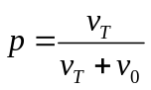
where 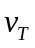 is the total amount of venom injected by all parasitoids the host encountered, and v₀ is the constant determining the rate of increase. It follows that, if all parasitoids inject venom, superparasitized hosts are more likely to be successfully killed, although the difference may be small.
If paralyzing the host is successful, there is scramble competition among the larvae. We assume the host can sustain a limited number of emerging adults (within-host carrying capacity, 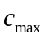). The survival probability of each larva is given by
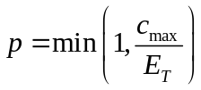

3. Reproduction: population dynamics, inheritance and mutation
Each parasitoid produces the number of their offspring that have survived larval competition; again each offspring inherits the traits of its parent with some mutation (see below). The hosts that have escaped parasitism reproduce, according to the Nicholson-Bailey model with density-dependence:
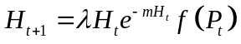
where λ is the host intrinsic growth rate and m its mortality due to density-dependence. 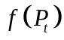 is the escape function (the fraction of hosts avoiding parasitism), as given in equation (4).

As the offspring inherits its parent’s traits, mutation occurs with a small probability (0.02). If multiple traits are subjected to evolution, one of the traits is chosen at random per mutation event. The new value for the offspring’s trait is drawn from a normal distribution around the old value, with σ = 0.01.
Parasitoid population size is expected to be an important factor in the evolutionary dynamics, as it affects the superparasitism rate and through this the evolution of both traits. At the same time, population size is affected by these traits as well, creating feedback between ecological and evolutionary dynamics. Moreover, both k and c_{max} affect the level of larval competition directly (k by affecting the rate of superparasitism, c_{max} by affecting the level of within-host competition), as well as indirectly by affecting parasitoid population size. To disentangle these effects, we also studied a version of the model with constant host and parasitoid population sizes. The implementation of parasitoid reproduction in this model and its results can be found in Appendix A.

Results

Evolution of a single trait

Although the three traits are expected to interact with one another, we first studied the evolution of each trait in isolation, keeping the other two traits constant. We analyzed four evolutionary scenarios, each for fixed and dynamic population sizes. In none of these scenarios we observed evolutionary branching in any of the traits. We nevertheless report here the direction of evolution in each scenario, as this will assist in understanding our results for simultaneous evolution of multiple traits.

1. Evolution of venom production
The optimal level of venom production is strongly dependent on the level of within-host competition, and decreases with increasing within-host carrying capacity (Figure 1a). Lowered within-host competition increases the probability that any eggs laid will survive into adulthood, and thus selects for higher fecundity. The second factor that affects the evolved level of venom production is the superparasitism rate. Both stronger aggregation of encounters (low k) and a higher parasitoid population size lead to lower venom production (population sizes corresponding to Figure 1a are shown in Figure 2). As superparasitism is more common, the probability of finding an unparasitized host decreases; when venom is only injected into unparasitized hosts, this means the amount of venom injected per host will increase even if total venom production remains the same. When comparing the actual amounts of venom injected into unparasitized hosts, the effect of superparasitism rate mostly disappears.
As increases, the parasitoid population increases in abundance, which causes a decrease in host abundance (Figure 2). For k ≥ 0.3 the average population sizes rapidly level off for ≥ 10 ; unless encounters are very strongly aggregated, the probability for a host to be found by more than two parasitoids in these cases is very low. Only when encounters are very strongly aggregated (k = 0.1) does parasitoid abundance continue to increase with . The abundance patterns under evolution of the other two traits are the same.
Although host and parasitoid abundances are expected to affect the course of evolution, all results described in this section were found to hold up in the model with fixed population sizes (Supplementary material, Appendix A, Figure A1). It is therefore the level of within-host competition, not the population sizes, that causes these patterns in evolution.

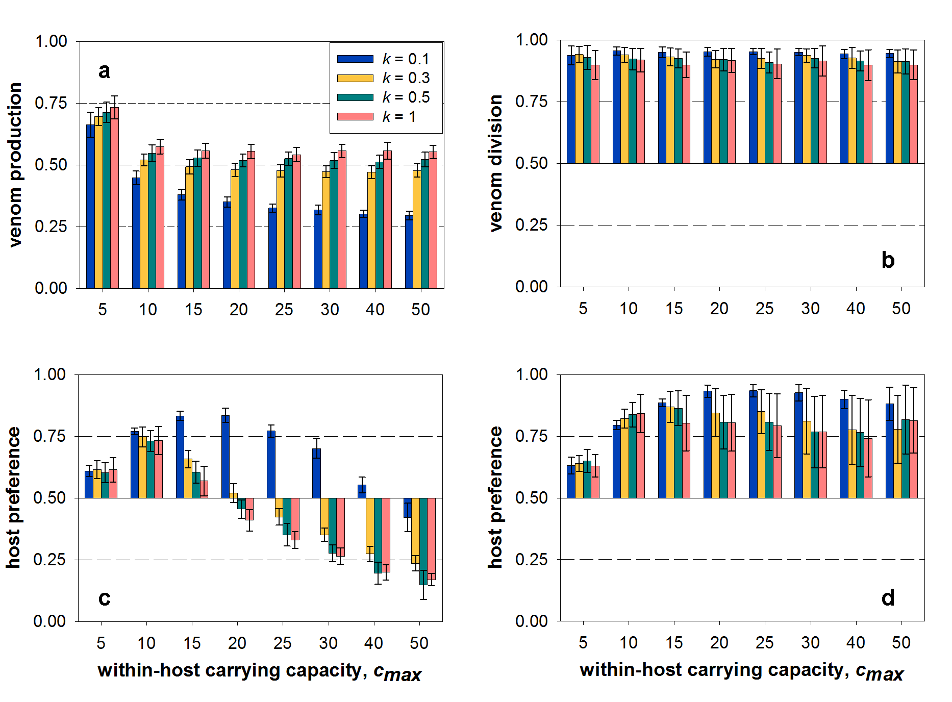
Figure 1. Single trait evolution for different values of k and c_{max}, keeping the other two traits constant. (a): evolution of venom production v; d_{c} = 0.5, d_{v} = 1.0, b = 1.0. (b): evolution of venom division d_{v}; v = 0.5, d_{c} = 0.5, b = 0. (c): evolution of host preference d_{c}; v = 0.5, d_{v} = 0.5, b = 0. (d): evolution of host preference d_{c}; v = 0.5, d_{v} = 1.0, b = 0. Bars represent mean +/- standard deviation of the population average of the trait under selection, calculated over 50 replicate simulation runs, recorded after 50,000 generations. Other parameters: a = 3.0∙10⁻⁵, c₀ = 5.0, v₀ = 0.1, λ = 1.3 and m = 2.0∙10⁻⁵.

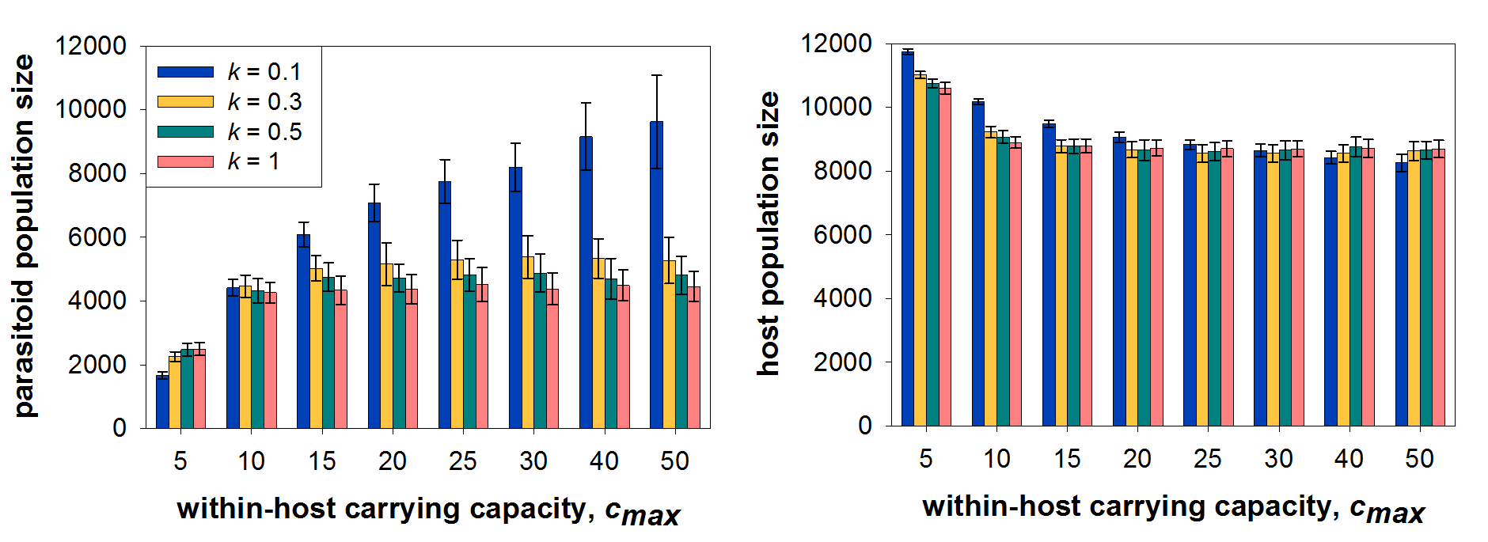
Figure 2. Parasitoid and host abundances corresponding to the evolutionary results in Figure 1a; all parameters the same as Figure 1a.

2. Evolution of venom division
Venom division always evolved in such a way that the vast majority of venom is injected into unparasitized hosts (Figure 1b). Both the level of aggregation and the level of within-host competition only have a small effect on the optimal division.

3. Evolution of host preference
We expect that the value that is assumed for the division of venom, , will significantly impact how preference evolves, because the amount of venom injected by superparasitizing females will determine the benefit, if any, to superparasitizing. For this reason we studied two scenarios, = 0.5 (equal distribution over unparasitized and parasitized hosts), and = 1 (only injecting venom into unparasitized hosts). These two scenarios are the biologically realistic extremes, showing the range in evolutionary outcomes that can theoretically occur.
Equal venom division. In the case where equal amounts of venom are injected regardless of the host’s parasitisation status, superparasitizing confers both costs (increased within-host competition) and benefits (multiple doses of venom, giving a higher chance that parasitism is successful). The relative strength of both determines in which direction preference will evolve, so the level of within-host competition is again the most important determining factor in the outcome of evolution (Figure 1c). When the within-host carrying capacity is small to intermediate, a preference for unparasitized hosts evolves; the preference is strongest for intermediate values of . However, as the severity of within-host competition decreases even further, the relative benefit of superparasitizing increases until it eventually outweighs the costs, leading to selection for a preference for parasitized hosts rather than unparasitized ones. A preference for unparasitized hosts evolves more readily when superparasitism rates are high (low k, high parasitoid population size). The increased level of within-host competition increases the cost of superparasitizing, and a higher carrying capacity is needed to counterbalance this and make superparasitizing pay off.
Venom restricted to unparasitized hosts. If superparasitizing females never inject additional venom, the outcome of evolution changes dramatically (Figure 1d). Any benefit of superparasitizing disappears, and consequently, a preference for unparasitized hosts always evolves. As in the previous scenario, the strongest preference evolves for intermediate values of . As increases further, the impact of within-host competition on larval survival diminishes, resulting in weaker selective pressure for avoiding competition by preferring unparasitized hosts. Moreover, directional selection becomes weak enough for genetic drift to become a prominent force, resulting in large amounts of variation between replicate simulation runs.

Multiple trait evolution

When all three traits are allowed to evolve simultaneously, the results change dramatically, especially for high within-host carrying capacity (Figure 3). While venom production shows the same pattern as when it evolves in isolation, the other two traits (venom division and host preference) interact for high values of . Venom division always evolved to a value close to 1 when host preference was fixed at = 0.5 (Figure 1b), but a preference for parasitized hosts causes venom division to become less biased, dropping down to 50/50 (and becoming biased towards injecting in parasitized hosts in many individual simulation runs; see also Figure 4). In turn, the more equal division of venom confers an advantage to superparasitizing females, causing a preference for superparasitizing to evolve (Figure 3c).

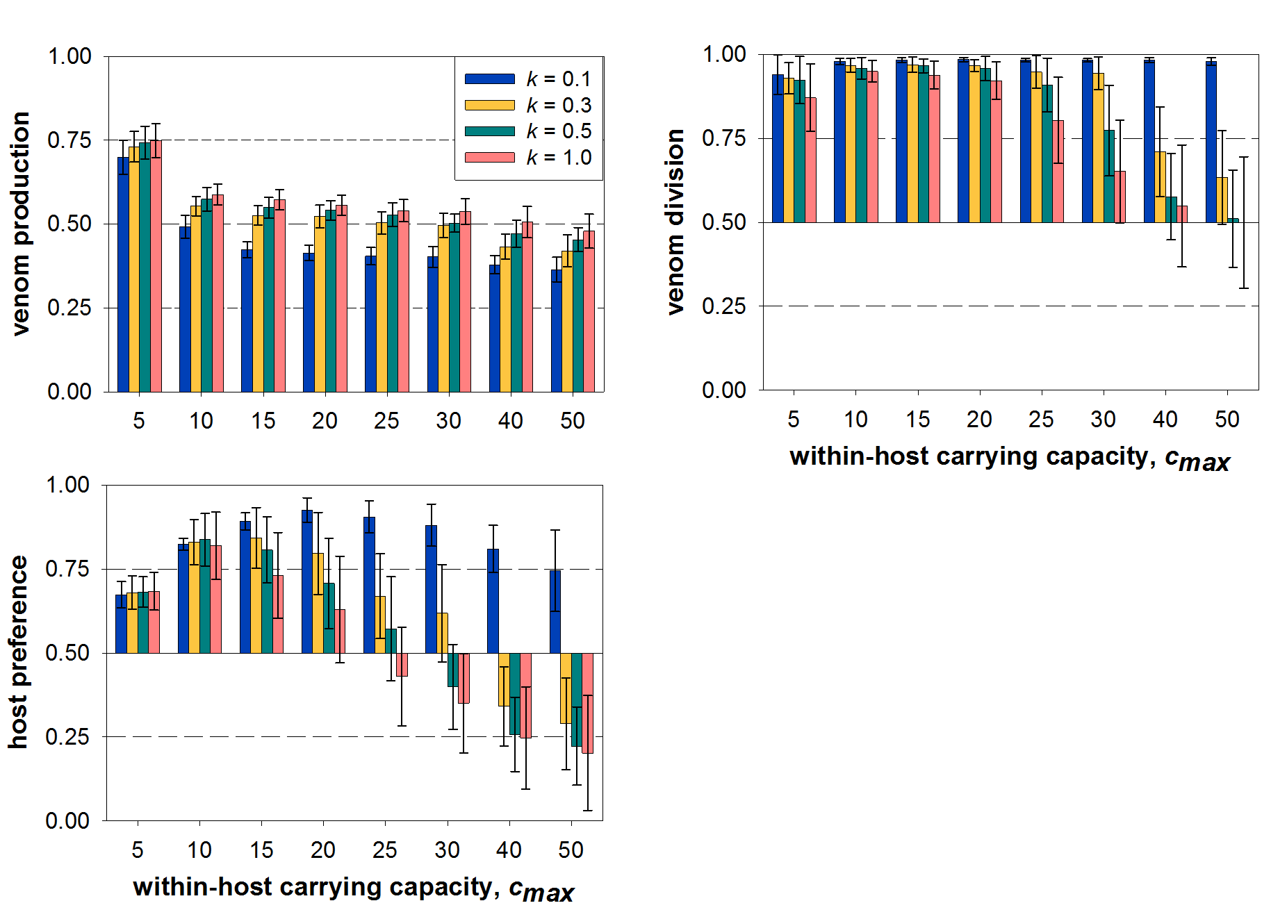
Figure 3. Simultaneous evolution of venom production, venom division and host preference. b = 1.0, v₀ = 0.1, a = 3.0∙10⁻⁵, c₀ = 5.0, λ = 1.3 and m = 2.0∙10⁻⁵.

The interaction between these two traits can also be observed between different replicate simulation runs with the same parameter values: there is a positive correlation between the population averages of the two traits, and a wide range of population averages is found for many parameter values (Figure 4). In particular, a preference for unparasitized hosts can still evolve even when the expected optimal strategy is a strong preference for parasitized hosts (Figure 4b-d), and this appears to be an evolutionarily stable strategy (see also Figure 5c). This feedback effect causes the large standard deviations seen for high values of in Figure 3b-c.
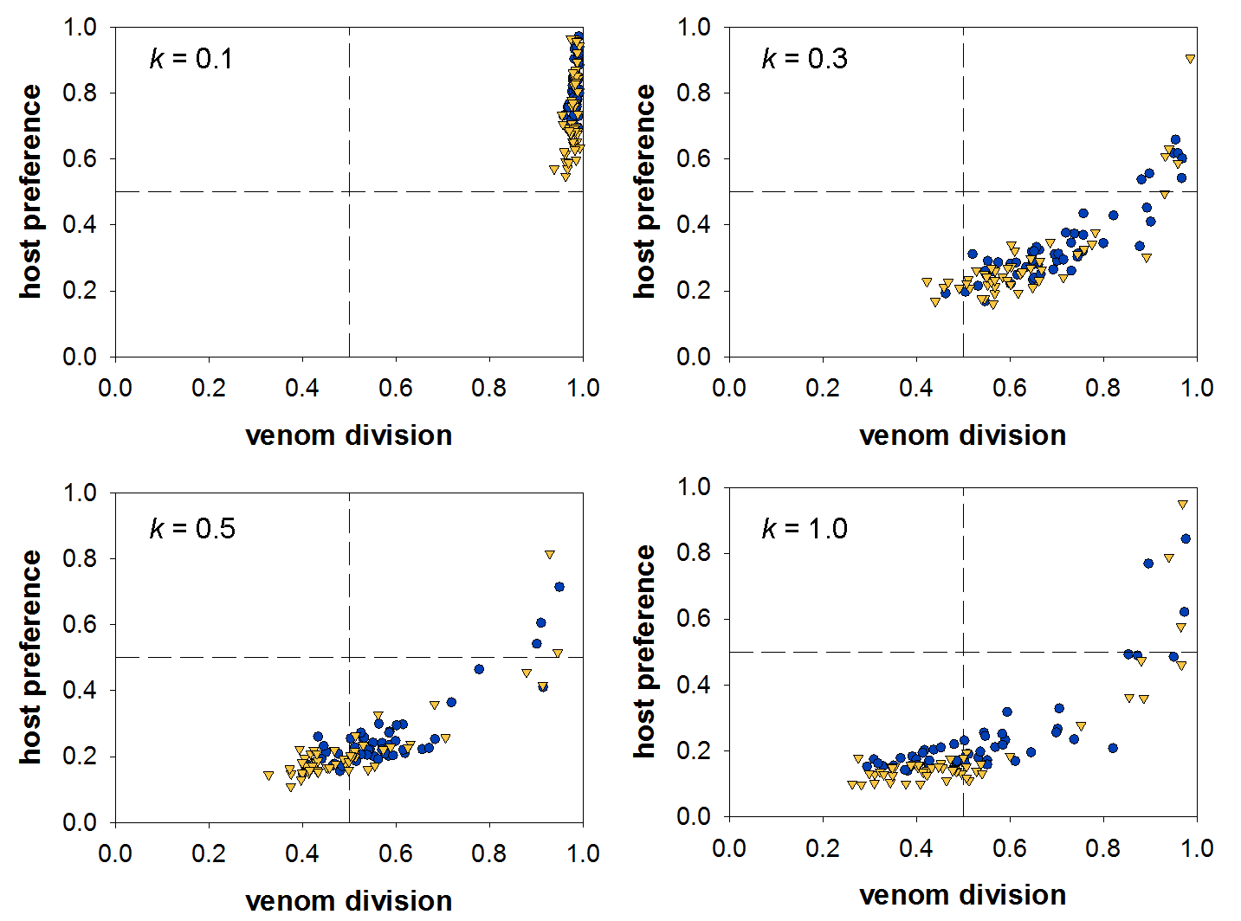
Figure 4. Multiple trait evolution results: population averages of the venom division () and host preference () traits for different values of k; symbols represent individual simulation runs. Stable coexistence did not occur in any simulation runs. Circles: = 40; triangles: = 50. All other parameters the same as in Figure 3b.

For part of the parameter range, we found evolutionary branching in all three traits, giving rise to two distinct strategies (Figure 5 shows examples of simulation runs in which evolutionary branching occurs). The U-strategy consists of producing venom and only laying eggs and injecting venom into unparasitized hosts. The P-strategy consists of producing no or very little venom, only laying eggs in parasitized hosts and taking advantage of the venom injected by the first-arrived female (Figure 5a). For this strategy, the venom division trait shows random drift after branching, because venom production is so low that selection on venom division is very weak. The P-strategy is always less abundant in the population (Figure 5a).
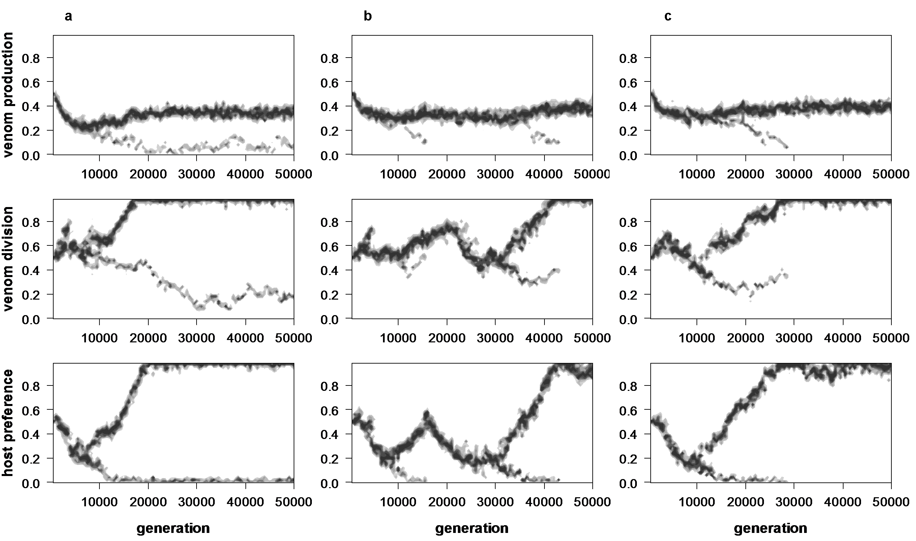
Figure 5. Individual simulation runs representative of three different evolutionary outcomes after branching occurs. (a): branching resulting in stable coexistence; (b): cycles of evolutionary branching and extinction of the P-strategy; (c): evolutionary branching and extinction of the P-strategy, followed by the survival of a single specialized U-strategy.

After branching occurs, there are three possible evolutionary scenarios that can follow, the first being stable coexistence of the two strategies (Figure 5a). In the other two cases, the P-strategy eventually goes extinct (Figure 5b-c). What happens next depends on how specialized the U-strategy is at the time the P-strategy goes extinct. When it is not yet completely specialized on using unparasitized hosts, all three of its traits evolve back to the branching point, and evolutionary branching occurs again (Figure 5b). However, if it is completely specialized (= 1, = 1), it remains specialized, and a monomorphic population of U-strategists persists (Figure 5c). This last result is consistent with the results shown in Figure 4: a monomorphic U-strategy, once reached, is an evolutionarily stable strategy.
The probability with which branching occurs, and with which it results in stable coexistence, depends on a number of parameters (Figure 6). The most crucial parameter is the within-host carrying capacity: for branching to occur, superparasitizing needs to pay off; low within-host competition (high values of ) promote branching. The other parameter that strongly affects branching is the costliness of venom production (Figure 6b): coexistence increases dramatically as venom production becomes more costly.
The effect of aggregation (k) is less dramatic, but still visible in both branching and coexistence. Very strong aggregation (k ≤ 0.1) inhibits branching and coexistence, as it results in a very high rate of superparasitism, increasing within-host competition and thereby the cost of superparasitizing. Conversely, increasing k decreases superparasitism and promotes branching by lowering within-host competition, but impairs coexistence because it leads to lower parasitoid abundance (see Figure 2a; branching and coexistence results with fixed population sizes are shown in Appendix A, Figure A3). The highest probability of coexistence thus occurs for intermediate values of k (0.3 – 0.7).
Figure 6 also shows the general effect of host and parasitoid population sizes: when host growth rate and parasitoid attack rate have values that sustain higher population sizes, branching and especially coexistence increase dramatically.
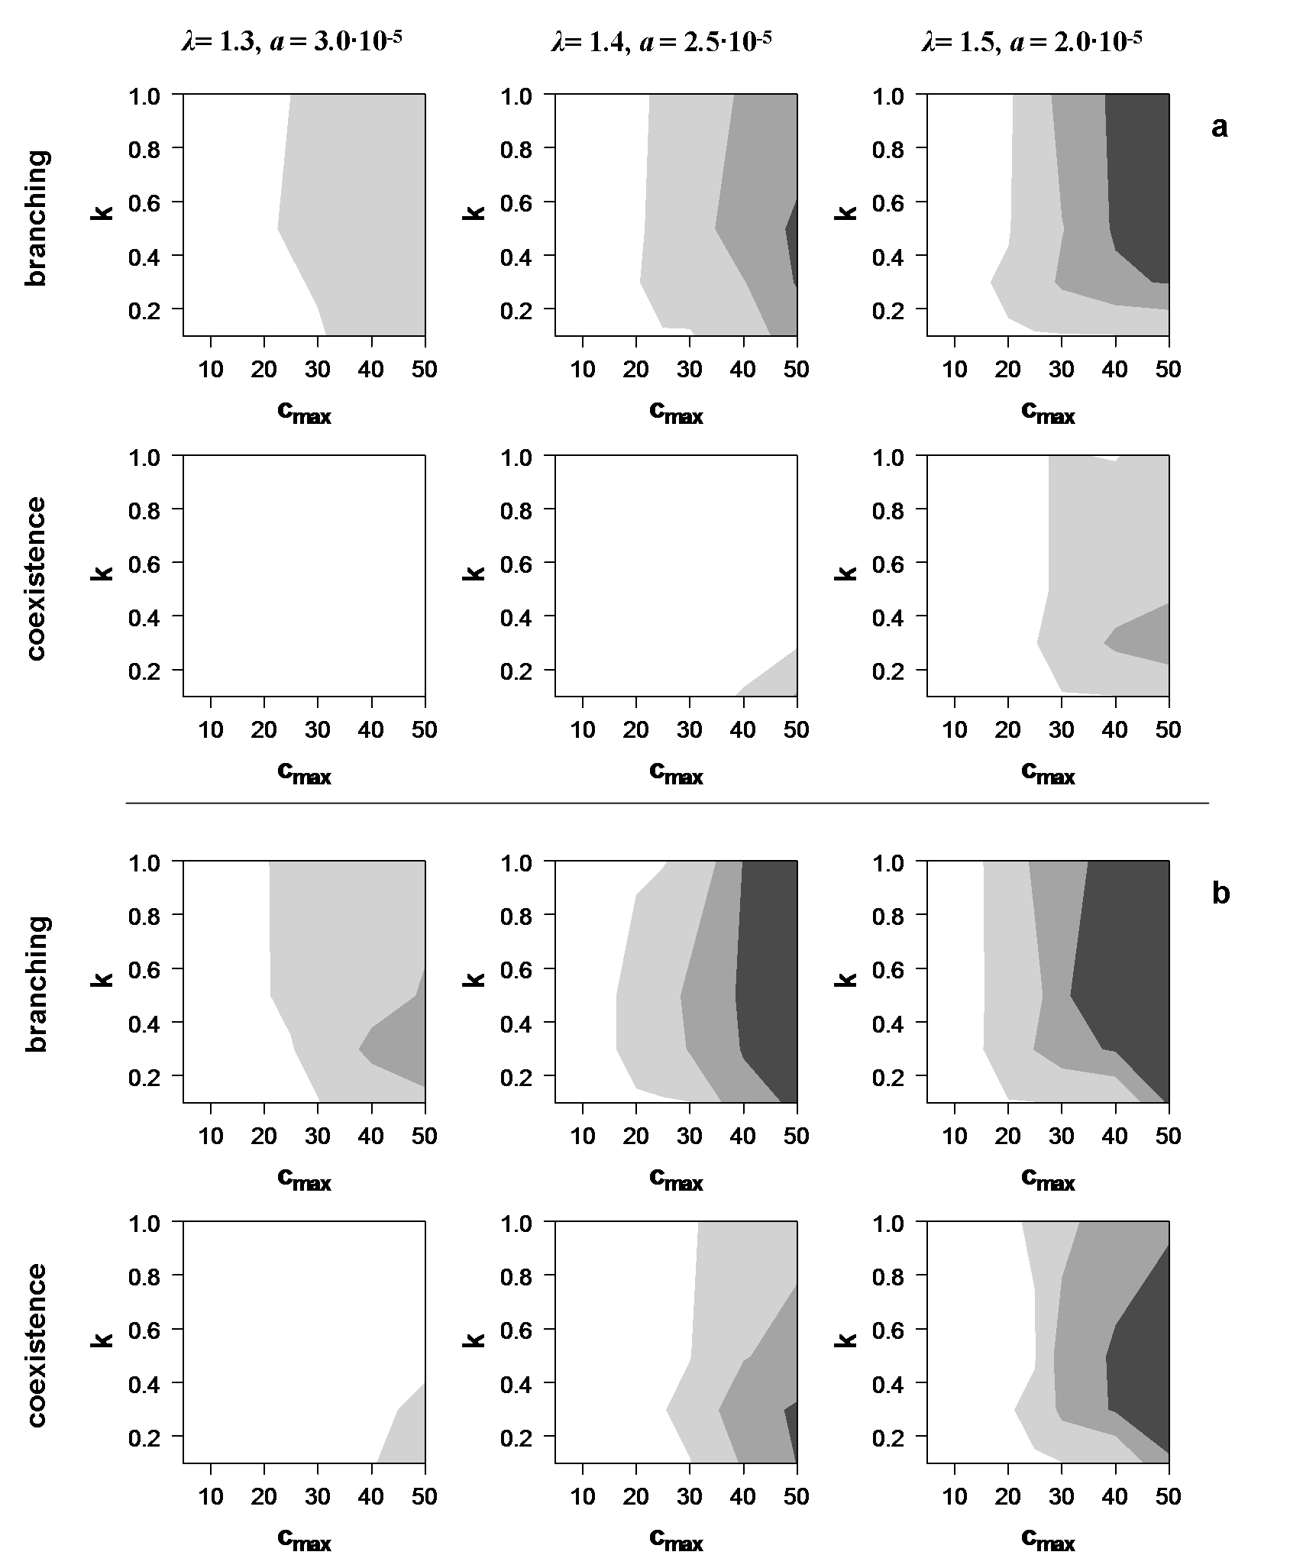
Figure 6. The frequency of evolutionary branching and coexistence of two strategies, for three combinations of host growth rate λ and parasitoid attack rate a. (a): low cost, b = 1.0; (b): high cost, b = 2.0. Other parameters: m = 2.0∙10⁻⁵, c₀ = 5.0, v₀ = 0.1. Colours denote the frequency, scored over 50 replicate simulation runs. White: no branching / coexistence; light grey: 0-50%; middle grey: 50-95%; dark grey: >95%.

Discussion

Existing models on clutch size decisions for gregarious parasitoids take an optimal foraging viewpoint, where the cost of superparasitizing is in time wasted on superparasitizing that could be spent searching for higher quality (unparasitized) hosts (Charnov and Skinner 1984; Parker and Courtney 1984; Skinner 1985; Strand and Godfray 1989); any other costs or benefits to superparasitism are disregarded. Moreover, these models typically focus on host-parasitoid interactions on a single patch, and do not incorporate population dynamics. While there are several models on the evolution of virulence in parasitoids incorporating Nicholson-Bailey population dynamics (Sasaki and Godfray 1999; Tuda and Bonsall 1999), the focus of these models is on the coevolution of parasitoid virulence and host resistance; none of them include superparasitism or within-host competition in their dynamics, and thus do not allow for any potential facilitative effects between parasitoids sharing a host.
In this study we developed a model to study the joint evolution of clutch size decisions and the evolution of virulence, here represented as the level of venom production. For this purpose we adapted a standard Nicholson-Bailey model for host-parasitoid dynamics; our most important modification is the introduction of a within-host carrying capacity. In the standard Nicholson-Bailey model, the number of parasitoid offspring emerging from a host is always the same, regardless of how many parasitoids encountered the host. This is unrealistic in a gregarious species like Nasonia vitripennis, in which intraspecific host sharing is common and superparasitized hosts contain larger broods than single-parasitized ones (Molbo and Parker 1996). The introduction of a within-host carrying capacity provides a more realistic model for gregarious parasitoids like Nasonia.
In this new framework, our results show that the single most important parameter determining the course of evolution across all scenarios is the within-host carrying capacity c_{max}. This is particularly the case for the evolution of host preference, because this parameter determines the level of within-host competition and thus the cost of superparasitizing. A preference for unparasitized hosts always evolves when within-host competition is the only factor under consideration for larval fitness; this is consistent with results of previous models on clutch size (Parker and Courtney 1984; Skinner 1985; Strand and Godfray 1989) that superparasitizing females should always lay fewer eggs than the first female. But when superparasitizing can confer an advantage in addition to the cost of higher larval competition, a preference for superparasitizing can evolve, but only if the costs of superparasitizing are sufficiently low.
Although various clutch size models include a within-host carrying capacity (Parker and Courtney 1984; Strand and Godfray 1989), they do not study the effect of this parameter on the relative clutch sizes for the first and subsequent females. Our results indicate that the largest bias towards laying eggs in unparasitized hosts should occur for an intermediate carrying capacity. When the carrying capacity is high, competition is low enough that superparasitizing does not confer substantial costs in larval survival, making it less necessary to discriminate between parasitized and unparasitized hosts. Conversely, when the carrying capacity is low, a strong preference for unparasitized hosts does not pay off either; one possible explanation is that very strong within-host competition makes it less profitable to lay most eggs on a single host.
Our most striking result is that, while evolution of a single trait always leads to a monomorphic equilibrium, the joint evolution of venom production, venom division, and host preference can lead to evolutionary branching into two distinct parasitisation strategies. Again, the within-host carrying capacity is the most crucial parameter in whether branching occurs and whether it can lead to stable coexistence: branching is impossible when within-host competition is too strong for superparasitizing to pay off.
If both strategies persist after evolutionary branching, this eventually always leads to two extreme strategies: one producing venom and only laying eggs in unparasitized hosts (U-strategy), and the other producing little or no venom and only superparasitizing, taking advantage of the venom produced by the first female (P-strategy). The P-strategy always occurs at a lower frequency than the U-strategy, which is expected because the P-strategy has to rely on hosts previously parasitized by the U-strategy. The relative frequencies of the two strategies are determined by the cost of producing venom. When venom production comes at a higher cost, the fecundity of the U-strategy decreases, which has two effects: first, fewer eggs are laid by the U-strategy in total, so its numbers go down even without within-host competition; and second, it suffers more from competition in superparasitized hosts. Together this makes the P-strategy a stronger competitor, increasing its relative abundance in the population.
In principle, stable coexistence of the two strategies is always possible when branching has occurred. In practice, the P-strategy often goes extinct stochastically due to its low population size. Stable coexistence is thus most likely when either the frequency of the P-strategy in the population is higher (high cost of venom production) or when the total parasitoid abundance is high (high host growth rate; likewise, in the fixed population model coexistence is promoted by high parasitoid abundance (Figure A3)). Similarly, reducing stochastic variation in population dynamics promotes coexistence. In our model the number of eggs laid during an encounter is drawn from a Poisson distribution, and coexistence was more common in a version of the model where the number of eggs laid was strictly equal to the genetically determined clutch size (results not shown).
In the setup of our model, we decided it was reasonable to include a “venom division” trait to our model, despite a lack of empirical evidence that parasitoids inject less venom into parasitized hosts. Removing this trait from the model does not qualitatively change any of the results. Most importantly, in a two-trait version of the simulation, branching and coexistence both occurred for a wider parameter range than in the three-trait version. The inclusion of the venom division trait allows parasitoids to economize on venom production, by injecting venom only into some of the hosts; without this trait, the costs for the U-strategy are higher, resulting in a higher incidence of both branching and stable coexistence (this result is similar to the effect of increasing the costliness of venom). Thus, the inclusion of this third trait constitutes a “worst-case scenario” with regard to evolutionary branching.
One limitation of our model is that it assumes asexual reproduction, directly prohibiting gene flow between the two strategies after branching has occurred. Cross-mating between individuals with different strategies would prohibit branching. Because the coexistence of the two strategies necessitates them sharing a host, this may seem unrealistic. However, theoretical work on sympatric speciation has shown that simultaneous evolution of the ecological traits and assortative mating traits is possible in sexual species (Dieckmann and Doebeli 1999). If assortative mating and reproductive isolation does evolve, this would effectively lead to speciation; the P-strategy would consist of high rates of multiparasitism as well as superparasitism, as is seen in the Nasonia system.

Implications for Nasonia evolution

Our model was inspired by two Nasonia species, Nasonia vitripennis and N. giraulti, that live in close sympatry in Eastern North America, often sharing the same hosts. N. giraulti is always found in close association with N. vitripennis, never parasitizing a patch by itself (Grillenberger et al. 2009; Daoust et al. 2012); multiparasitism between these two species occurs at a high rate in the field (Grillenberger et al. 2009). Most remarkably, while N. vitripennis avoids multiparasitism, N. giraulti prefers hosts parasitized by N. vitripennis over unparasitized hosts (S. Pérez-Vila et al, accepted).
This study was partly motivated by the question whether this combination of parasitization strategies in Nasonia could evolve sympatrically. In terms of our results, N. vitripennis is the U-strategy while N. giraulti is the P-strategy. Consistent with our results, N. giraulti is far less common in the field than N. vitripennis (Grillenberger et al. 2009; Daoust et al. 2012). Our model predicts that the most important parameters determining N. giraulti’s abundance, both in absolute numbers and relative to N. vitripennis, are the within-host carrying capacity and the costliness of venom production. The carrying capacity in North America is around 25-30 (see Table 1), but data on the costliness of venom is lacking. Such data would allow us to test our predictions on the relative abundances of N. giraulti and N. vitripennis in the field. Also consistent with our result is the fact that N. vitripennis has a holarctic distribution, whereas N. giraulti has a very limited geographical distribution, occurring only in a small region in North America. N. vitripennis’s strategy is present in all evolutionary outcomes, including those in which the P-strategy has gone extinct.
The parasitization strategies of both Nasonia species are not as extreme as the strategies that evolve in our simulations. One possible explanation for this is that the two Nasonia species are still diverging; it may even be that stable coexistence is not possible for these two species, and N. giraulti may go extinct before complete specialization is reached. Alternatively, the extreme strategies found in our simulations could be an artefact of the model setup. Most importantly, our model by necessity assumes that, even after branching, the two strategies are part of one single population. While there is strong overlap in the distributions of N. vitripennis and N. giraulti in the field (the latter is typically found in association with the former, Grillenberger et al. 2009; Daoust et al. 2012), their association is likely weaker than the single-population scenario in our simulations. If their distributions in the field are partly non-overlapping, decreasing the frequency of encounters between individuals with different strategies, the resulting strategies are likely to be less extreme. A two-population model is needed to study the course of evolution under lower degrees of interspecific association, and to study what degree of association is necessary for evolutionary divergence to be feasible at all.
As noted in the previous section, a mechanism for assortative mating is required to prevent gene flow from disrupting the evolved polymorphism. Such a mechanism exists between these two species: while N. vitripennis mates after emergence from the host, N. giraulti mates almost exclusively within the host (Drapeau and Werren 1999; Leonard and Boake 2006), generating assortative mating that appears to be strong enough for N. giraulti to have abandoned species-specific chemical mate recognition (Buellesbach et al. 2013). This type of mating may have evolved during speciation, effectively reproductively isolating the incipient species.
Not much is known about the mechanisms of speciation in the Nasonia complex, and whether it was sympatric or allopatric in origin. It has been speculated that reproductive isolation caused by species-specific Wolbachia bacteria may have played a role (Bordenstein et al. 2001), although there is no Wolbachia-induced incompatibility between N. giraulti and N. oneida, the two most recenty diverged sibling species that occur in sympatry (Raychoudhury et al. 2010), indicating that cytoplasmic incompatibility is not required for speciation. Likewise, it is unclear why speciation has occurred several times in North America and never in the rest of the world, despite N. vitripennis being distributed holarctically; or if evolutionary branching has also taken place elsewhere, why N. giraulti’s parasitization strategy has gone extinct everywhere but in North America. Our results indicate that speciation occurs more readily with a higher within-host carrying capacity. Comparing field data on offspring numbers per host between Europe and North America, there does appear to be a trend for American hosts to have higher carrying capacities, but this difference is not statistically significant (Table 1).

Table 1. Summary of average offspring per host found in field studies done in Europe and North America.
Reference | study area | host | offspring / host
Grillenberger et al. 2008 | Hoge Veluwe / Schlüchtern | Calliphora / Unspecified | 14.77 ± 9.94
Molbo and Parker 1996 | Sweden | Calliphora, Protocalliphora | 25.61 ± 16.91
Peters and Abraham 2010 ª | Germany | Calliphora | 9.3
Peters and Abraham 2010 ª | Germany | Protocalliphora | 21.3
Peters and Abraham 2010 ª | Germany | Potemia | 9.6
Grillenberger et al. 2009 | New York | Unspecified | 22.0 (subset of nests)
Daoust et al. 2012 | Quebec | Protocalliphora | 30.66 ± 20.78  27.83 ± 14.82  29.64 ± 9.24  20.63 ± 10.01 | N. vitripennis
 |  |  |  | N. giraulti
S. Pérez-Vila, in prep | New York | Protocalliphora | 26.69 ± 13.52
S. Pérez-Vila, in prep | New York | Average over all | 24.71 ± 13.95
ªNo standard deviations were reported in this study

Our model provides a plausible mechanism by which speciation may have occurred, although evidence is still only circumstantial . A study on the whole genomes of Nasonia species found evidence of rapid directional selection on venom genes between N. vitripennis and N. giraulti (Werren et al. 2010), but this possibly merely reflects the fact that N. vitripennis is a generalist using many different host species and N. giraulti is a specialist on Protocalliphora spp., two strategies that require different venom proteins. Furthermore, its closest sibling species N. oneida performs poorly on its own compared to when several females are allowed to parasitize simultaneously, suggesting it benefits from superparasitism. While N. giraulti has a preference for multiparasitizing, it is unclear precisely what benefit it gains from this behaviour. Data comparing the numbers and fitness of N. vitripennis and N. giraulti offspring, either in single parasitizations or under super- or multiparasitism, would give more insight into the costs and benefits of sharing a host to both species, but is still lacking.
Further empirical studies are needed to determine whether the main predictions of our model hold up: (1) that N. giraulti offspring benefit from multiparasitizing (and that N. vitripennis offspring do not); (2) that N. giraulti’s venom production is lower or that it has a lower potency, having a lowered ability to kill the host or to modify its metabolism to suit the offspring’s needs. Answering these questions will bring us closer to understanding the evolutionary origin of N. giraulti’s peculiar parasitization behaviour and super- and multiparasitism in general.

Acknowledgements

We thank Saleta Pérez-Vila, Leo Beukeboom and the Evolutionary Genetics Group for helpful discussions during the writing of this manuscript. The research of EvV and RSE is supported by the Netherlands Foundation for Scientific Research (NWO).

References
Alleyne, M., and N. E. Beckage. 1997. Parasitism-induced effects on host growth and metabolic efficiency in tobacco hornworm larvae parasitized by Cotesia congregata. Journal of insect physiology 43:407-424.
Bakker, K., J. J. M. van Alphen, F. H. D. van Batenburg, N. van der Hoeven, H. W. Nell, W. T. F. H. van Strien-van Liempt, and T. C. J. Turlings. 1985. The function of host discrimination and superparasitization in parasitoids. Oecologia 67:572-576.
Bordenstein, S. R., F. P. O'Hara, and J. H. Werren. 2001. Wolbachia-induced incompatibility precedes other hybrid incompatibilities in Nasonia. Nature 409:707-710.
Breeuwer, J. A. J., and J. H. Werren. 1990. Microorganisms associated with chromosome destruction and reproductive isolation between two insect species. Nature 346:558-560.
Buellesbach, J., J. Gadau, L. W. Beukeboom, F. Echinger, R. Raychoudhury, J. H. Werren, and T. Schmitt. 2013. Cuticular hydrocarbon divergence in the jewel wasp Nasonia: evolutionary shifts in chemical communication channels? Journal of Evolutionary Biology 26:2467-2478.
Charnov, E. L., and S. W. Skinner. 1984. Evolution of host selection and clutch size in parasitoid wasps. Florida Entomologist 67:5-21.
Cusson, M., M. Laforge, J. Regniere, C. Beliveau, D. Trudel, J. C. Thireau, G. Bellemare, N. Keirstead, and D. Stolz. 2002. Multiparasitism of Choristoneura fumiferana by the ichneumonid Tranosema rostrale and the tachinid Actia interrupta: occurrence in the field and outcome of competition under laboratory conditions. Entomologia Experimentalis et Applicata 102:125-133.
Daoust, S. P., J. Savage, T. L. Whitworth, M. Belisle, and J. Brodeur. 2012. Diversity and abundance of ectoparasitic blow flies Protocalliphora (Diptera: Calliphoridae) and their Nasonia (Hymenoptera: Pteromalidae) parasitoids in tree swallow nests within agricultural lands of Southern Quebec, Canada. Annals of the Entomological Society of America 105:471-478.
Darling, D. C., and J. H. Werren. 1990. Biosystematics of Nasonia (Hymenoptera: Pteromalidae): two new species reared from birds nests in North-America. Annals of the Entomological Society of America 83:352-370.
de Vis, R. M. J., H. Mendez, and J. C. van Lenteren. 2003. Comparison of foraging behavior, interspecific host discrimination, and competition of Encarsia formosa and Amitus fuscipennis. Journal of Insect Behavior 16:117-152.
Desjardins, C. A., F. Perfectti, J. D. Bartos, L. S. Enders, and J. H. Werren. 2010. The genetic basis of interspecies host preference differences in the model parasitoid Nasonia. Heredity 104:270-277.
Dieckmann, U., and M. Doebeli. 1999. On the origin of species by sympatric speciation. Nature 400:354-357.
Dorn, S., and N. E. Beckage. 2007. Superparasitism in gregarious hymenopteran parasitoids: ecological, behavioural and physiological perspectives. Physiological Entomology 32:199-211.
Drapeau, M. D., and J. H. Werren. 1999. Differences in mating behaviour and sex ratio between three sibling species of Nasonia. Evolutionary Ecology Research 1:223-234.
Flanagan, K., S. West, and H. Godfray. 1998. Local mate competition, variable fecundity and information use in a parasitoid. Animal Behaviour 56:191-198.
Godfray, H. C. J. 1994. Parasitoids: behavioural and evolutionary ecology. Princeton University Press, Princeton.
Godfray, H. C. J. 1986. Clutch size in a leaf-mining fly (Pegomya nigritarsis, Anthomyiidae). Ecological Entomology 11:75-81.
Grillenberger, B. K., T. Koevoets, M. N. Burton-Chellew, E. M. Sykes, D. M. Shuker, L. V. De Zande, R. Bijlsma, J. Gadau, and L. W. Beukeboom. 2008. Genetic structure of natural Nasonia vitripennis populations: validating assumptions of sex-ratio theory. Molecular ecology 17:2854-2864.
Grillenberger, B. K., L. van de Zande, R. Bijlsma, J. Gadau, and L. W. Beukeboom. 2009. Reproductive strategies under multiparasitism in natural populations of the parasitoid wasp Nasonia (Hymenoptera). Journal of Evolutionary Biology 22:460-470.
Guzo, D., and D. B. Stoltz. 1985. Obligatory multiparasitism in the tussock moth, Orgyia leucostigma. Parasitology 90:1-10.
Haeckermann, J., A. S. Rott, and S. Dorn. 2007. How two different host species influence the performance of a gregarious parasitoid: host size is not equal to host quality. Journal of Animal Ecology 76:376-383.
Hardy, I. C. W., N. T. Griffiths, and H. C. J. Godfray. 1992. Clutch size in a parasitoid wasp: a manipulation experiment. Journal of Animal Ecology 61:121-129.
Heimpel, G. E., and J. A. Rosenheim. 1998. Egg limitation in parasitoids: A review of the evidence and a case study. Biological Control 11:160-168.
Ivens, A. B. F., D. M. Shuker, L. W. Beukeboom, and I. Pen. 2009. Host acceptance and sex allocation of Nasonia wasps in response to conspecifics and heterospecifics. Proceedings of the Royal Society B-Biological Sciences 276:3663-3669.
Iwasa, Y., Y. Suzuki, and H. Matsuda. 1984. Theory of oviposition strategy of parasitoids.1. Effect of mortality and limited egg number. Theoretical population biology 26:205-227.
Leonard, J. E., and C. R. B. Boake. 2006. Site-dependent aggression and mating behaviour in three species of Nasonia (Hymenoptera : Pteromalidae). Animal Behaviour 71:641-647.
Magdaraog, P. M., T. Tanaka, and J. A. Harvey. 2013. Inter- and intra-specific host discrimination in gregarious and solitary endoparasitoid wasps. Biocontrol 58:745-754.
Mahmoud, A. M. A., and U. T. Lim. 2008. Host discrimination and interspecific competition of Trissolcus nigripedius and Telenomus gifuensis (Hymenoptera : Scelionidae), sympatric parasitoids of Dolycoris baccarum (Heteroptera : Pentatomidae). Biological Control 45:337-343.
May, R. M. 1978. Host-parasitoid systems in patchy environments: a phenomenological model. Journal of Animal Ecology 47:833-844.
Molbo, D., and E. D. Parker. 1996. Mating structure and sex ratio variation in a natural population of Nasonia vitripennis. Proceedings of the Royal Society B-Biological Sciences 263:1703-1709.
Nicholson, A. J., and V. A. Bailey. 1935. The balance of animal populations, part 1. Proceedings of the Zoological Society of London 3:551-598.
Parker, G. A., and S. P. Courtney. 1984. Models of clutch size in insect oviposition. Theoretical population biology 26:27-48.
Peters, R. S., and R. Abraham. 2010. The food web of parasitoid wasps and their non-phytophagous fly hosts in birds' nests (Hymenoptera: Chalcidoidea, and Diptera: Cyclorrhapha). Journal of Natural History 44:625-638.
Rabinovich, J. E., M. T. Jorda, and C. Bernstein. 2000. Local mate competition and precise sex ratios in Telenomus fariai (Hymenoptera : Scelionidae), a parasitoid of triatomine eggs. Behavioral Ecology and Sociobiology 48:308-315.
Raychoudhury, R., C. A. Desjardins, J. Buellesbach, D. W. Loehlin, B. K. Grillenberger, L. Beukeboom, T. Schmitt, and J. H. Werren. 2010. Behavioral and genetic characteristics of a new species of Nasonia. Heredity 104:278-288.
Rivero, A., and S. A. West. 2005. The costs and benefits of host feeding in parasitoids. Animal Behaviour 69:1293-1301.
Rivero, A., and S. A. West. 2002. The physiological costs of being small in a parasitic wasp. Evolutionary Ecology Research 4:407-420.
Sasaki, A., and H. C. J. Godfray. 1999. A model for the coevolution of resistance and virulence in coupled host-parasitoid interactions. Proceedings of the Royal Society B-Biological Sciences 266:455-463.
Skinner, S. W. 1985. Clutch size as an optimal foraging problem for insects. Behavioral Ecology and Sociobiology 17:231-238.
Strand, M. R., and H. C. J. Godfray. 1989. Superparasitism and ovicide in parasitic Hymenoptera: theory and a case study of the ectoparasitoid Bracon hebetor. Behavioral Ecology and Sociobiology 24:421-432.
Sykes, E. M., T. M. Innocent, I. Pen, D. M. Shuker, and S. A. West. 2007. Asymmetric larval competition in the parasitoid wasp Nasonia vitripennis: a role in sex allocation? Behavioral Ecology and Sociobiology 61:1751-1758.
Tena, A., A. Kapranas, F. Garcia-Mari, and R. F. Luck. 2008. Host discrimination, superparasitism and infanticide by a gregarious endoparasitoid. Animal Behaviour 76:789-799.
Tuda, M., and M. B. Bonsall. 1999. Evolutionary and population dynamics of host-parasitoid interactions. Researches on Population Ecology 41:81-91.
van Alphen, J. J. M., and M. E. Visser. 1990. Superparasitism as an adaptive strategy for insect parasitoids. Annual Review of Entomology 35:59-79.
van Baaren, J., G. Boivin, and J. P. Nénon. 1994. Intraspecific and interspecific host discrimination in two closely related egg parasitoids. Oecologia 100:325-330.
Vet, L. E. M., A. Datema, A. Janssen, and H. Snellen. 1994. Clutch size in a larval pupal endoparasitoid: consequences for fitness. Journal of Animal Ecology 63:807-815.
Vet, L. E. M., M. Meyer, K. Bakker, and J. J. M. van Alphen. 1984. Intra- and interspecific host discrimination in Asobara (Hymenoptera) larval endoparasitoids of Drosophilidae: comparison between closely related and less closely related species. Animal Behaviour 32:871-874.
Visser, M. E., J. J. M. Van Alphen, and L. Hemerik. 1992. Adaptive superparasitism and patch time allocation in solitary parasitoids: an ESS model. Journal of Animal Ecology 61:93-101.
Wang, X., Z. Yang, H. Wu, and J. R. Gould. 2008. Effects of host size on the sex ratio, clutch size, and size of adult Spathius agrili, an ectoparasitoid of emerald ash borer. Biological Control 44:7-12.
Weisser, W. W., and A. I. Houston. 1993. Host discrimination in parasitic wasps: when is it advantageous? Functional Ecology 7:27-39.
Werren, J. H., S. Richards, C. A. Desjardins, and O. Niehuis. 2010. Functional and evolutionary insights from the genomes of three parasitoid Nasonia species. Science 327:343-348.
White, J. A., and D. A. Andow. 2008. Benefits of self-superparasitism in a polyembryonic parasitoid. Biological Control 46:133-139.
Whiting, A. R. 1967. The biology of the parasitic wasp Mormoniella vitripennis [=Nasonia brevicornis] (Walker). Quarterly Review of Biology 42:333-&.
Wylie, H. G. 1970. Oviposition restraint of Nasonia vitripennis (Hymenoptera: Pteromalidae) on hosts parasitized by other hymenopterous species. Canadian Entomologist 102:886-&.
Zaviezo, T., and N. Mills. 2000. Factors influencing the evolution of clutch size in a gregarious insect parasitoid. Journal of Animal Ecology 69:1047-1057.

Appendix A: Simulation model with fixed population sizes

Simulation setup: parasitoid reproduction

In this version of the model, both host and parasitoid abundances are kept constant. To determine each parasitoid’s contribution to the next generation, its fitness is determined by the number of its offspring that survive larval competition, normalized over the population so the parasitoid with the most offspring has a fitness of 1. For each parasitoid of the new generation, a parent is drawn from the population with a probability equal to its fitness. The offspring parasitoid inherits the genetic traits of its parent, with some mutation as described in the main Methods.

Results

The results show all the same patterns observed in the simulation with ecological host-parasitoid dynamics, confirming that the results of the original model are independent of any indirect effects of parameters on host and parasitoid abundances.

1. Single and multiple trait evolution

The results of all four single trait evolution scenarios (evolution of venom v, evolution of venom division , evolution of host preference with 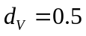 and 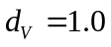) closely resemble the results of the original model (compare Figure A1 with Figure 1), as did the results for multiple trait evolution (compare Figure A2 with Figure 3). For a more detailed discussion on each scenario, see the main Results.
In addition, parasitoid population size itself has a clear effect on evolution in all three traits. A higher population size increases the superparasitism rate, leading to lower venom production (Figure A1a, A2a), a stronger bias towards injecting venom in unparasitized hosts (Figure A1b, A2b) and a stronger preference for laying eggs in unparasitized hosts (Figure A1c-d, A2c).

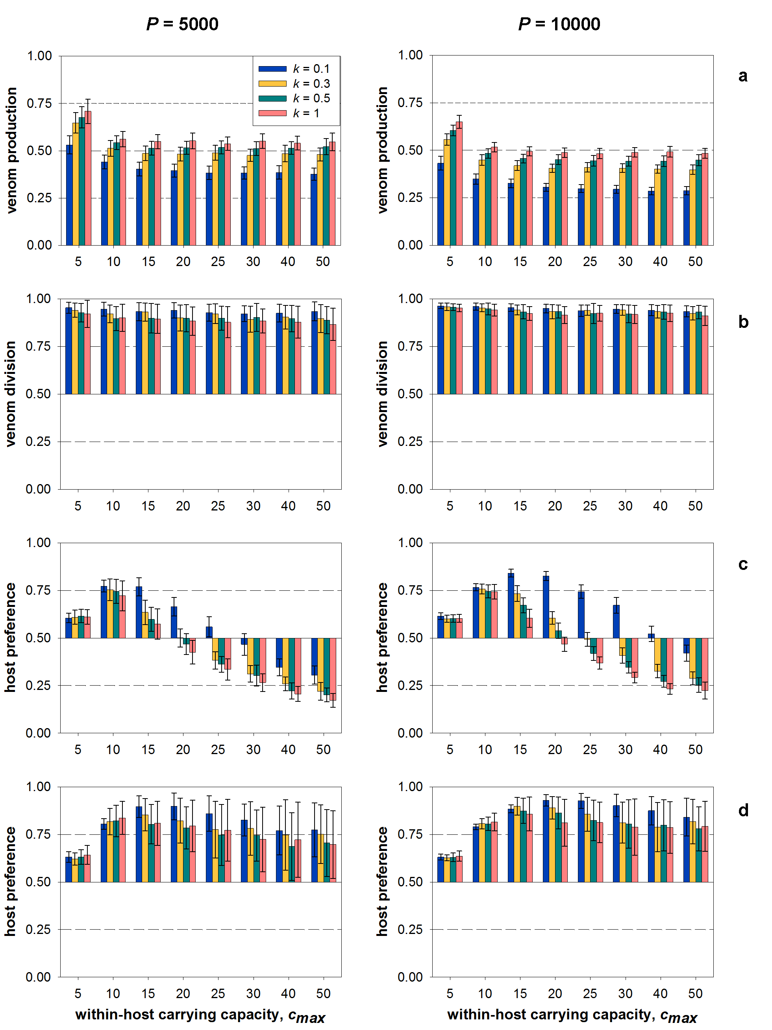

Figure A1. Single trait evolution for different values of k and c_{max}, keeping the other two traits constant. (a): evolution of venom production v; d_{c} = 0.5, d_{v} = 1.0, b = 1.0. (b): evolution of venom division d_{v}; v = 0.5, d_{c} = 0.5, b = 0. (c): evolution of host preference d_{c}; v = 0.5, d_{v} = 0.5, b = 0. (d): evolution of host preference d_{c}; v = 0.5, d_{v} = 1.0, b = 0. Other parameters: a = 3.0∙10⁻⁵, c₀ = 5.0, v₀ = 0.1 and H = 5000.

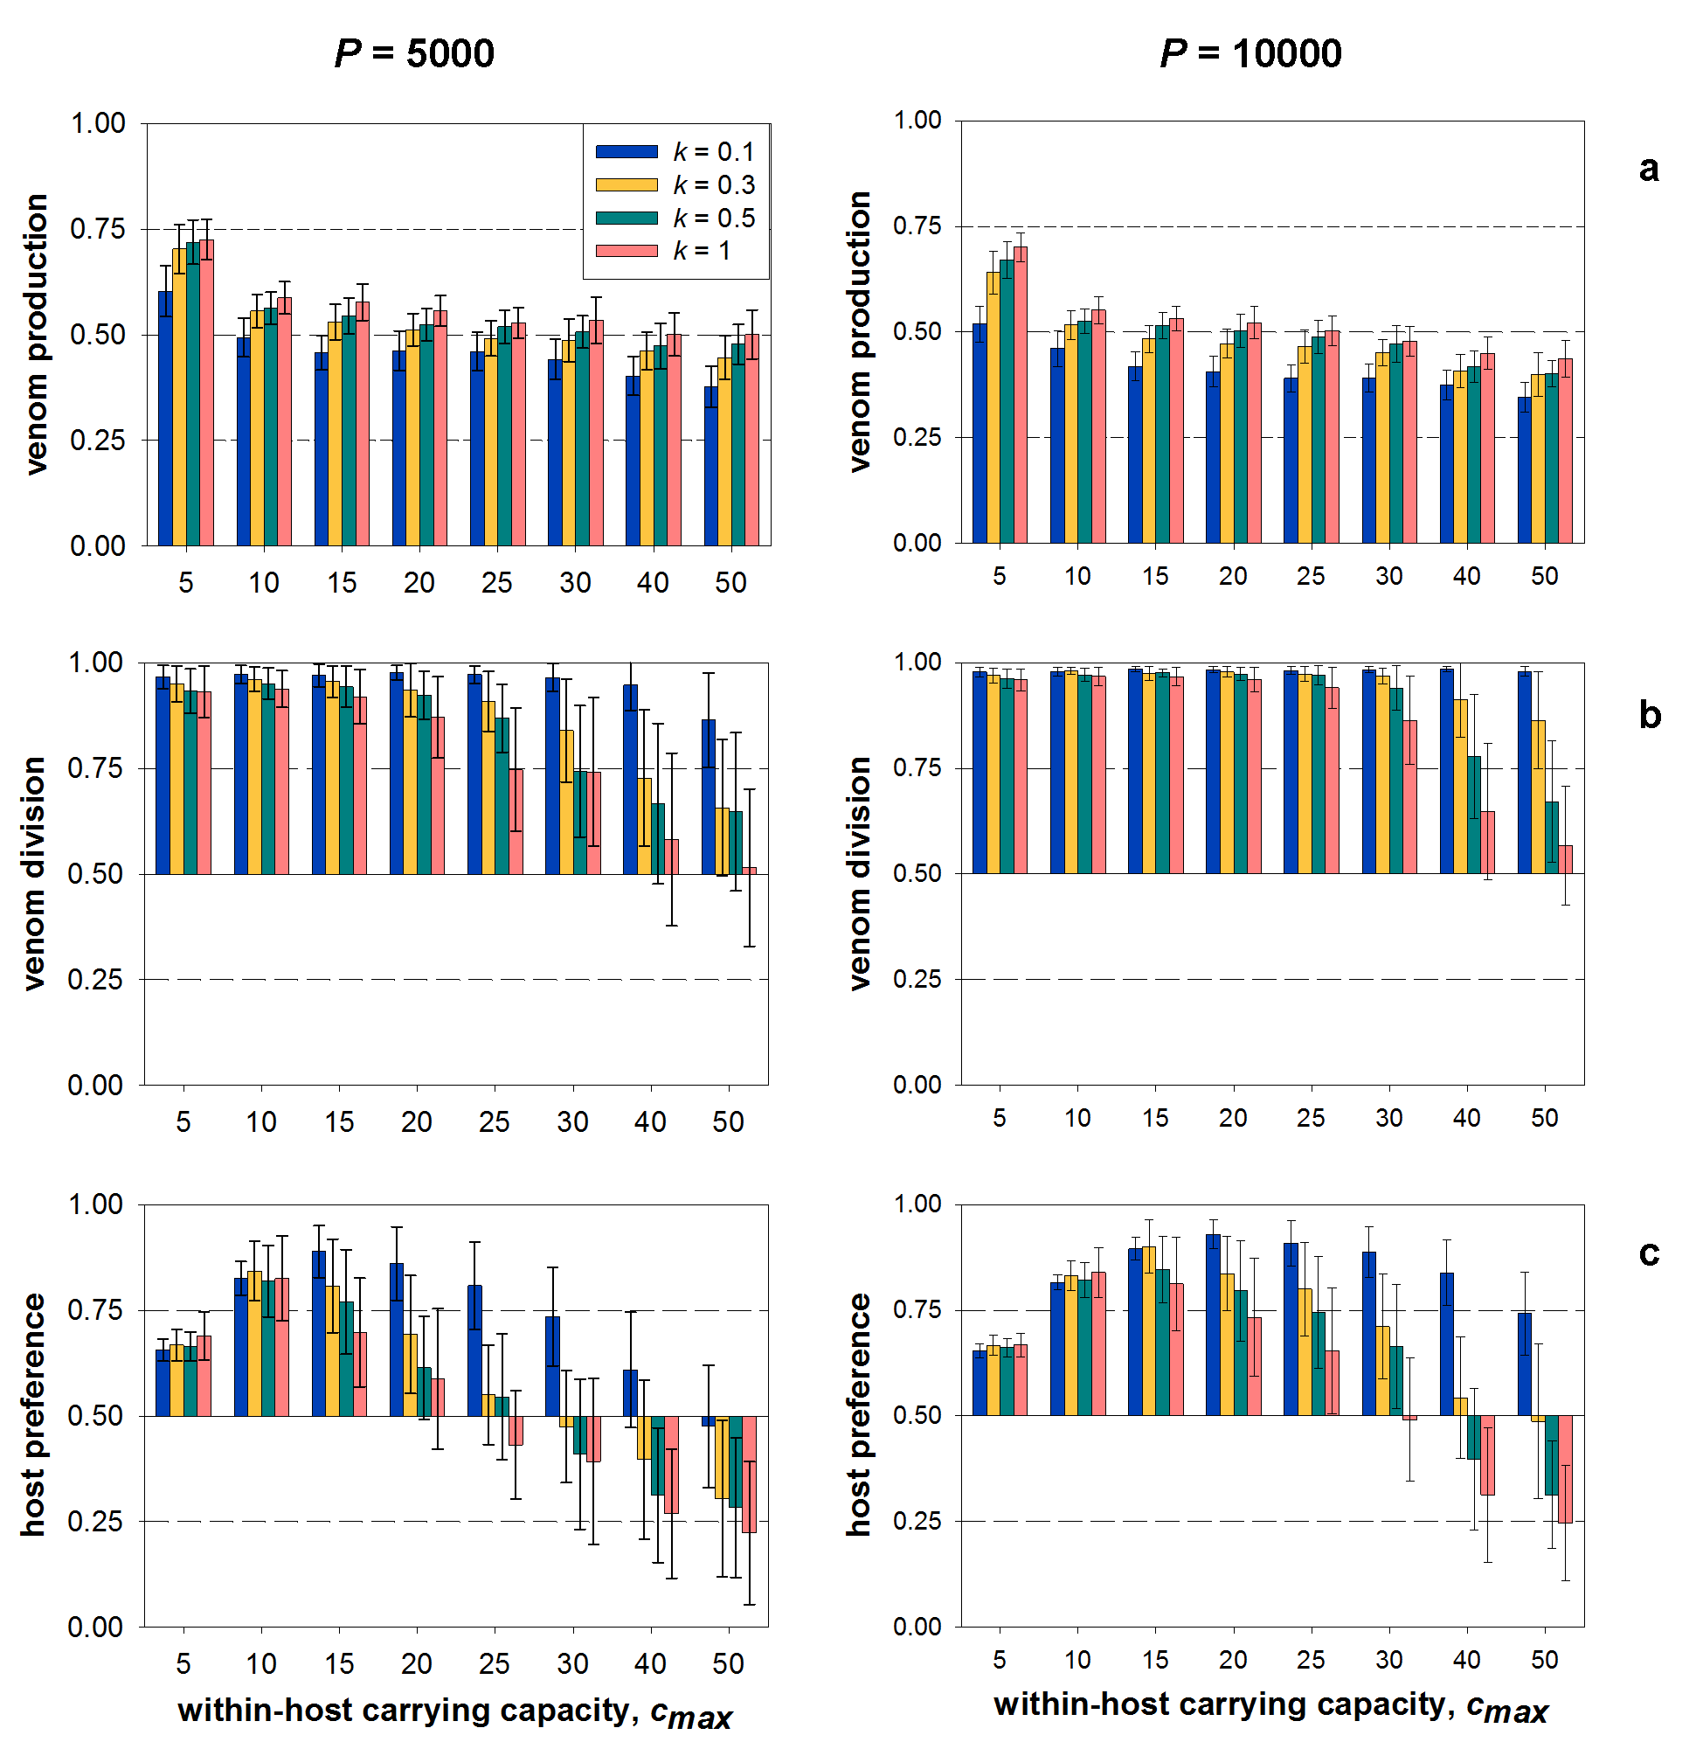
Figure A2. Simultaneous evolution of venom production, venom division and host preference. b = 1.0, v₀ = 0.1, a = 3.0∙10⁻⁵, c₀ = 5.0, λ = 1.3 and m = 2.0∙10⁻⁵.

3. Evolutionary branching and coexistence

Evolutionary branching into two parasitisation strategies was observed in this model under essentially the same conditions as the original (Figure A3). As in the original results, low within-host competition (high ), large parasitoid population sizes and a high costliness of venom production all promote both branching and coexistence. The main difference is the effect of the clumping parameter k: in contrast with the results shown in Figure 6, where intermediate values for k (0.3-0.7) promoted coexistence and both higher and lower values impaired it, in this model both branching and coexistence are promoted by high values for k (relatively weak clumping of encounters). Higher values for k themselves, all else remaining equal, thus promote coexistence by lowering the superparasitism rate, thereby lowering within-host competition and making superparasitism a more viable strategy. The negative effect of high k on coexistence shown in the original results (Figure 6) can be explained by the fact that parasitoid population size decreases with k, thereby reducing the probability that coexistence is stable in the long run.
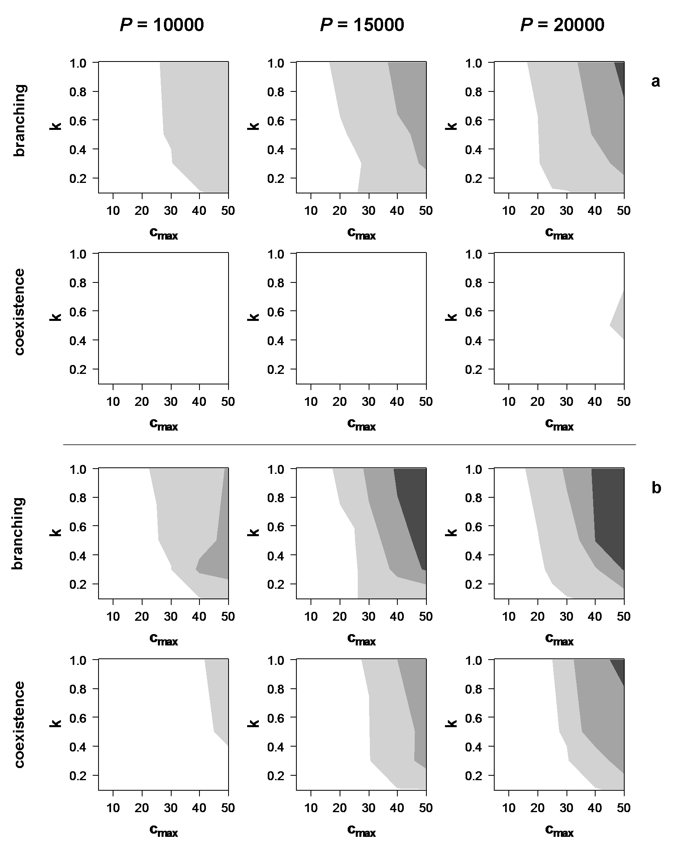
Figure A3. The frequency of evolutionary branching and coexistence of two strategies, for three values for parasitoid abundance P. (a): low cost, b = 1.0; (b): high cost, b = 2.0. Other parameters: H = 5000, a = 3.0∙10⁻⁵, c₀ = 5.0, v₀ = 0.1. Colours denote the frequency, scored over 50 replicate simulation runs. White: no branching / coexistence; light grey: 0-50%; middle grey: 50-95%; dark grey: >95%.

